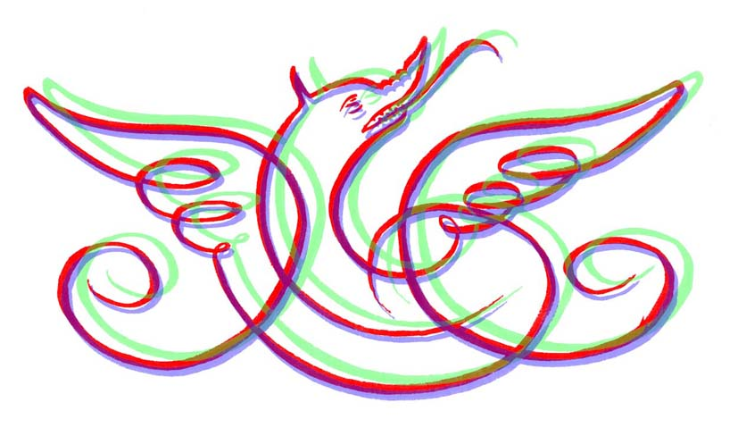
The Baskerville Society
c/o Birmingham City University, The Parkside Building, 5 Cardigan Street, Birmingham B4 7BD

telephone 0121 331 5871, email caroline.archer@bcu.ac.uk

Call for Pledges
MATTHEW BOULTON’S BASKERVILLE FAMILY BIBLE

On 26 March 2020, Boulton’s Baskerville family bible will be auctioned in London. This particular bible is arguably one of Baskerville’s most important volumes due to the quality of its bindings and the use of his endpapers. Annotated by a contemporary hand with details of the Boulton family, it is also of great significance to Birmingham as it represents the relationship between the printer John Baskerville and the industrialist Matthew Boulton, two of the most influential figures in the city’s history. We feel very strongly that the bible should remain in its ancestral home and made publicly available.

A consortium of city heritage organisations, led by the Baskerville Society, has been formed in order to bid for the bible at auction and ensure the volume remains in Birmingham. If successful in our bid, the bible will be housed at the Cadbury Research Library (CRL) at the University of Birmingham which has the resources to provide appropriate care for the book, together with its other Baskerville holdings, and make it available to the public in perpetuity.

As the bible is to be sold at auction it is impossible to predict exactly how much it will fetch; but it may sell for a considerable sum. Because of this uncertainty, rather than fundraising to help with the purchase, we are inviting individuals and organisations to make financial pledges which we can call in if needed. Unfortunately, time is against us and we would require pledges to be made by Friday 21 March 2020 at the latest.

If you agree to become a pledgor, you are promising to make a contributory gift towards the purchase of Boulton’s Baskerville family bible. Your gift may be called on in full should we have to pay a high price for the bible, or in part if the bible sells for less than expected. We would not call in funds until after the auction. While the bible will be fully owned by the CRL it will have been purchased with the assistance of the generous gifts of individuals and organisations whose support will be fully acknowledged. If you would like to make a pledge then please complete the attached document, or contact Caroline Archer or Malcolm Dick using the details below.

We do hope you will give some thought to becoming a pledgor and help us secure this important example of Birmingham’s history and rare piece of typographic heritage so that it can be cared for and enjoyed by current and future generations.

Thank you.

Caroline Archer (caroline.archer@bcu.ac.uk)
Malcolm Dick (m.m.dick@bham.ac.uk)

26 February 2020

